Design Concept & Rationale
The core of insurance brokerage is bridging the gap between the client and protection. The logo needs to represent this connection and the broad spectrum of assets they cover (Car, House, Valuables, Small Business).
We will combine three powerful elements into one cohesive, modern mark:
- The Shield: The ultimate symbol of protection and security.
- The "I" or "R": Using the leading letter to create a distinctive brand mark.
- The Path/Link: Representing the "Broker" connection.

Logo Options
Here are two distinct, modern directions for the IRS Brokers logo.
Option 1: The Secure Connection
This option focuses on the "Broker" as the connection point and the "IRS" as the secure foundation. It is sophisticated, modern, and highly versatile.
- The Mark (Logomark): A geometric line forms a single, abstracted roof-like structure or an upward-pointing arrow. This single symbol is enclosed within or forms the structure of a stylized, minimalist shield, showing of a Gem or Jewellery and Vehicles.
- Typography: "IRS" is set in a bold, strong, modern sans-serif font (e.g., Montserrat, Lato, or a custom variation). The letters are clean and clearly spaced. "Brokers" is positioned directly below "IRS" in a lighter weight of the same font family, conveying balance and clarity.
- Visual Feel: This logo is balanced, sturdy, and aspirational. The upward curve suggests growth, future-readiness, and proactive protection. It looks like a trustworthy insurance institution. 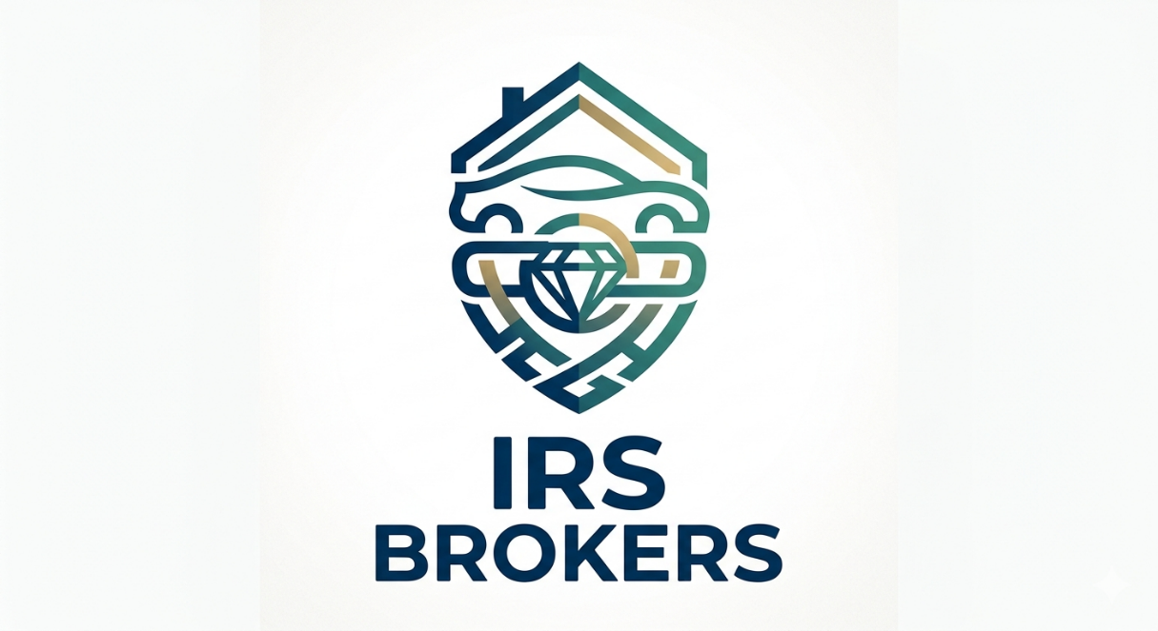
Option 2: The Adaptive Shield (A "House" for All Assets)
This option focuses on the idea that IRS Brokers offers "Comprehensive Protection" for everything—cars, houses, valuables, and businesses.
- The Mark (Logomark): A classic, solid shield shape is used. Instead of a solid form, the shield is created by four interconnected, stylized graphic elements. Each element subtly represents one of their core services, converging to form the shield:
  - A subtle roofline (House)
  - An angular line (Car)
  - A circular element (Valuables/Gem)
  - A linear base (Business/Structure) At the centre where these elements meet, the letters "I R S" are subtly formed within the negative space.
- Typography: "IRS BROKERS" is set in a single line of strong, clean, modern sans-serif. The font has rounded edges, giving it an approachable yet professional feel.
- Visual Feel: This logo is complex yet cohesive. It visually tells the story of "one partner, many protections." It feels comprehensive, integrated, and client-centric.
